Ideation Phase
Define the Problem Statements

Date | 31 January 2025
Team ID | LTVIP2026TMIDS34879
Project Name | Online Payments Fraud Detection Using Machine Learning
Maximum Marks | 2 Marks

Customer Problem Statement Template:
The Customer Problem Statement template is used to understand the challenges faced by users in online payment systems, especially related to fraud detection. It helps the team focus on critical issues such as security, accuracy, and user trust while designing the solution.
A well-defined customer problem statement enables the team to identify risks in digital transactions, understand user concerns about fraud, and develop an effective machine learning-based system to detect suspicious activities. It also helps in empathizing with both customers and financial institutions, ensuring the system is reliable, fast, and user-friendly.
By clearly understanding these problems, the team can design a solution that minimizes fraud, reduces false alerts, and improves overall user confidence in online payment platforms.
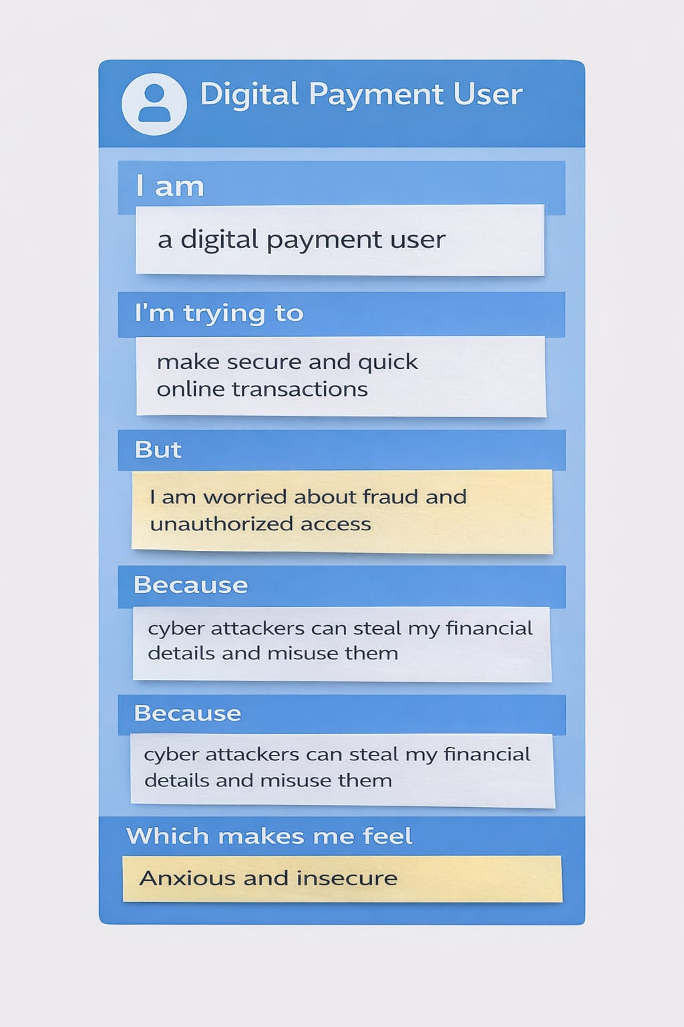

Example:
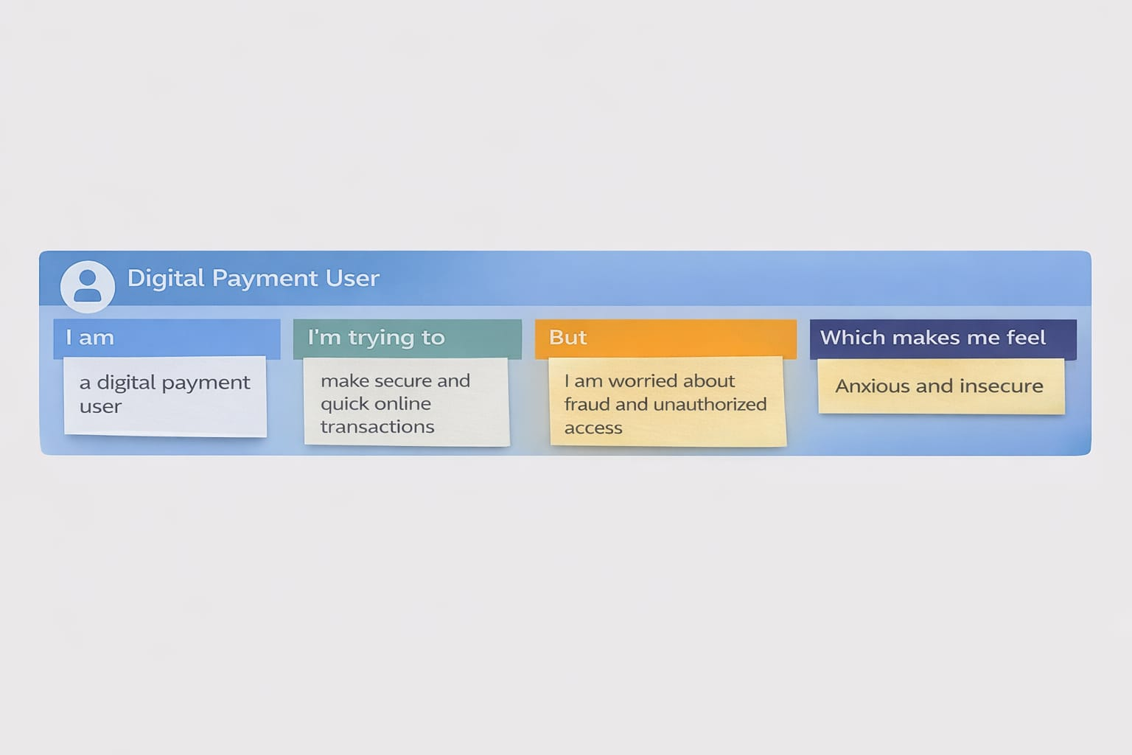
Problem Statement (PS) | I am (Customer) | I’m trying to | But | Because | Which makes me feel
PS-1 | I am an online banking user | I’m trying to make secure digital payments | But I am worried about fraud and unauthorized transactions | Because cybercriminals can misuse my financial details | Which makes me feel anxious and unsafe
PS-2 | I am a bank/payment service provider | I’m trying to detect fraudulent transactions accurately | But traditional systems fail to detect new fraud patterns | Because they rely on fixed rules and lack adaptability | Which makes me feel challenged in ensuring customer trust

